SIMATS ENGINEERING

ASSESSMENT TOOL 1

COURSE NAME: Database Management Systems COURSE CODE: CSA05

QUESTIONS
Q.N  o | Question | Bloom's Level
1 | Given a set of relations and sample data, write SQL queries to retrieve specific information using joins and subqueries, and explain the logic used.  Bloom’s Level: BL3 – Apply | BL4 – Analyze
2 | Using relational algebra, formulate expressions to solve complex queries such as retrieving records that satisfy multiple conditions across relations.  Bloom’s Level: BL4 – Analyse | BL5 – Evaluate
3 | Given a real-world scenario (e.g., banking or student system), design a relational schema and construct appropriate SQL queries for data retrieval and updates. Bloom’s Level: BL6 – Create | BL6 – Create
4 | Analyse a given SQL query with nested subqueries and predict its output, explaining each step of execution.  Bloom’s Level: BL4 – Analyze | BL6 – Create
5 | Compare different SQL approaches (joins vs subqueries) for solving the same problem and evaluate their efficiency. Bloom’s Level: BL5 – Evaluate | BL4 – Analyze
6 | Design and implement views for a database system to provide restricted data access, and justify their use for security and abstraction.  Bloom’s Level: BL6 – Create | BL5 – Evaluate
7 | Given a database schema, write relational algebra expressions and convert them into equivalent SQL queries, analyzing differences in representation.  Bloom’s Level: BL4 – Analyze | BL4 – Analyze

8 | Optimize a set of inefficient SQL queries by restructuring them using joins, indexing concepts, or views, and evaluate performance improvements.  Bloom’s Level: BL5 – Evaluate | BL5 – Evaluate
9 | Develop a complex SQL query involving grouping, aggregation, and nested queries to solve a real-world problem.  Bloom’s Level: BL6 – Create | BL6 – Create
10 | Given multiple relations, analyze the query requirements and decide whether to use views, joins, or subqueries, justifying your choice with reasoning.  Bloom’s Level: BL5 – Evaluate | BL5 – Evaluate

QUESTION-1:
Given a set of relations and sample data, write SQL queries to retrieve specific information using joins and subqueries, and explain the logic used.
Bloom’s Level: BL3 – Apply

ANSWER:
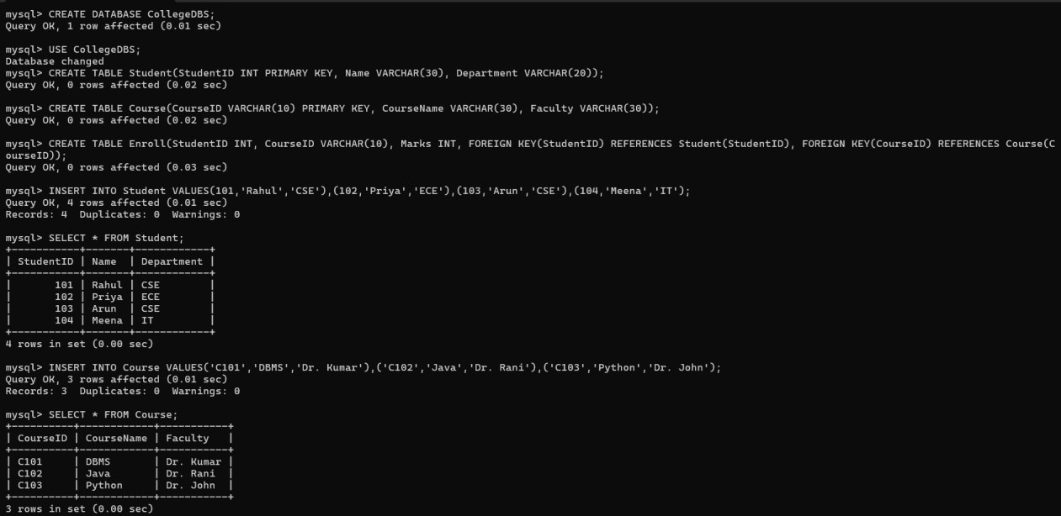

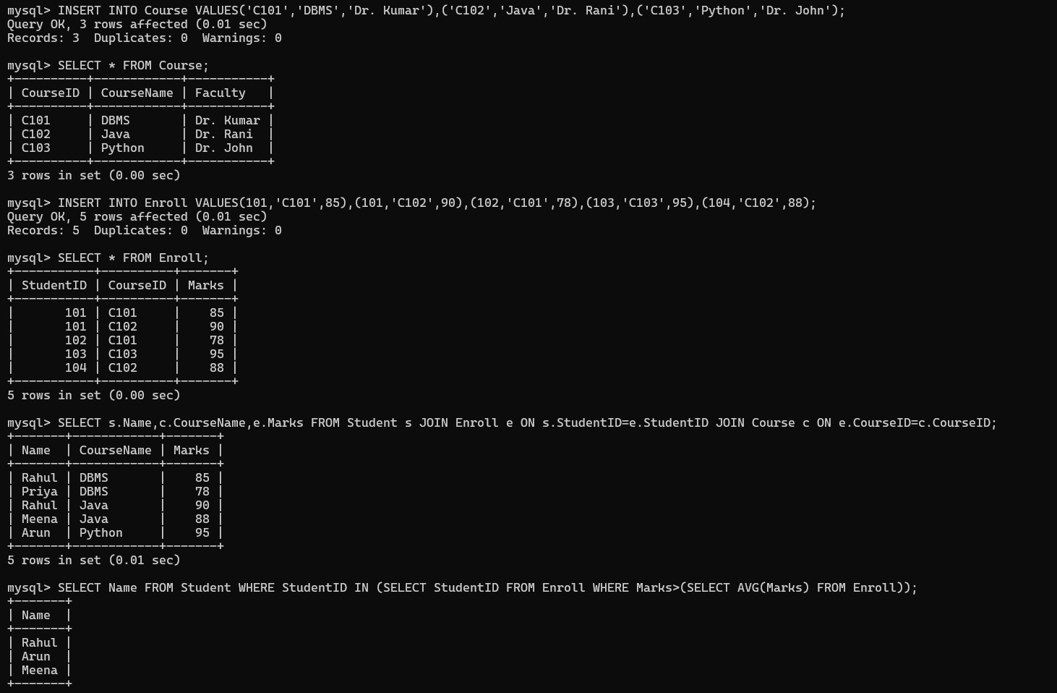

QUESTION: 2
Using relational algebra, formulate expressions to solve complex queries such as retrieving records that satisfy multiple conditions across relations.
Bloom’s Level: BL4 – Analyse

ANSWER:
RELATIONAL ALGEBRA:
R1 ← Student ⋈ Student.StudentID=Enroll.StudentID Enroll R2 ← R1 ⋈ Enroll.CourseID=Course.CourseID Course
R3 ← σ Department='CSE' ∧ Marks>80 ∧ CourseName='DBMS' (R2) Answer ← π Name, CourseName, Marks (R3)

In one line:
πName,CourseName,Marks(σDepartment='CSE'∧ Marks>80 ∧
CourseName='DBMS'(Student ⋈ Enroll ⋈ Course))

QUESTION: 3
Given a real-world scenario (e.g., banking or student system), design a relational schema and construct appropriate SQL queries for data retrieval and updates. Bloom’s Level: BL6 – Create

ANSWER:
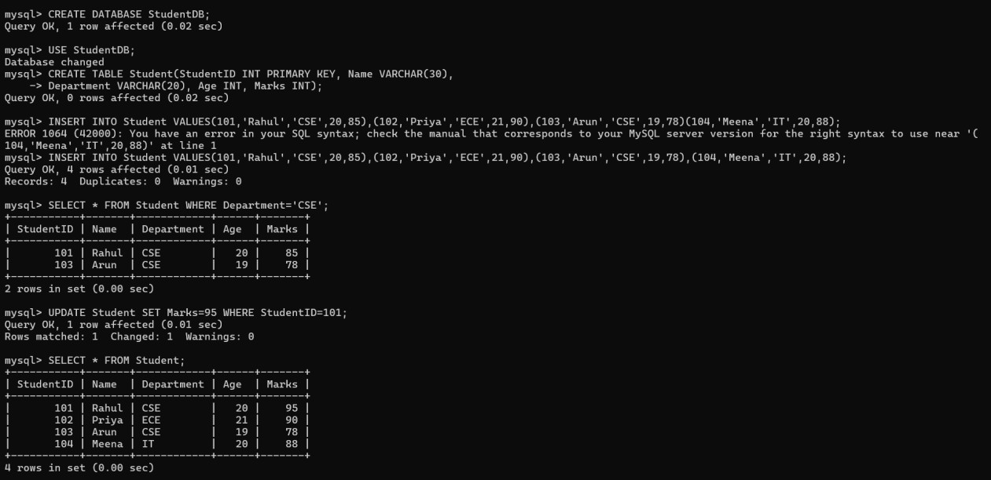

QUESTION:4
Analyse a given SQL query with nested subqueries and predict its output, explaining each step of execution.
Bloom’s Level: BL4 – Analyze

OUTPUT:
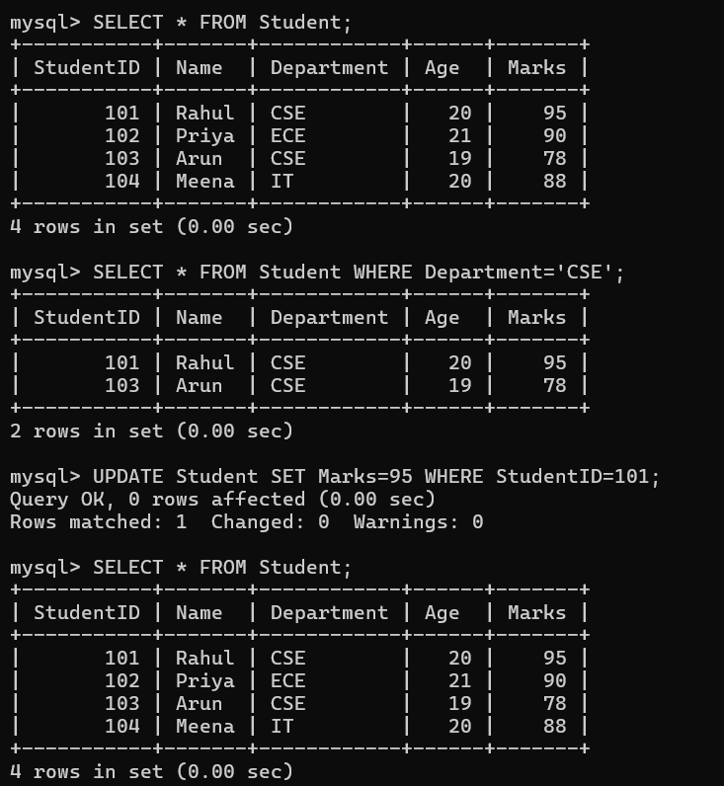

QUESTION: 5
Compare different SQL approaches (joins vs subqueries) for solving the same problem and evaluate their efficiency. Bloom’s Level: BL5 – Evaluate

OUTPUT:
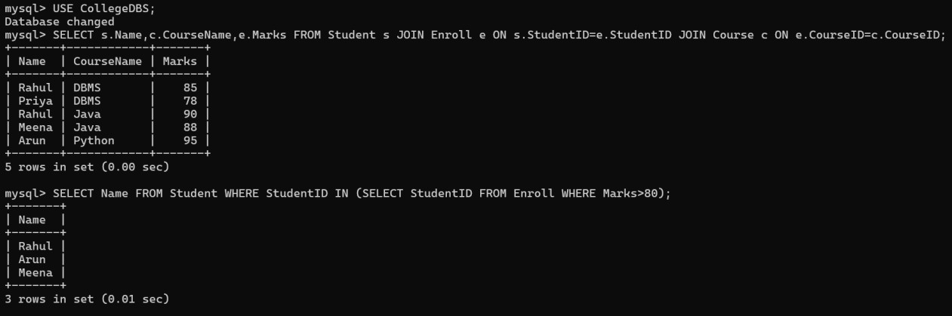

QUESTION: 6
Design and implement views for a database system to provide restricted data access, and justify their use for security and abstraction.
Bloom’s Level: BL6 – Create

ANSWER:
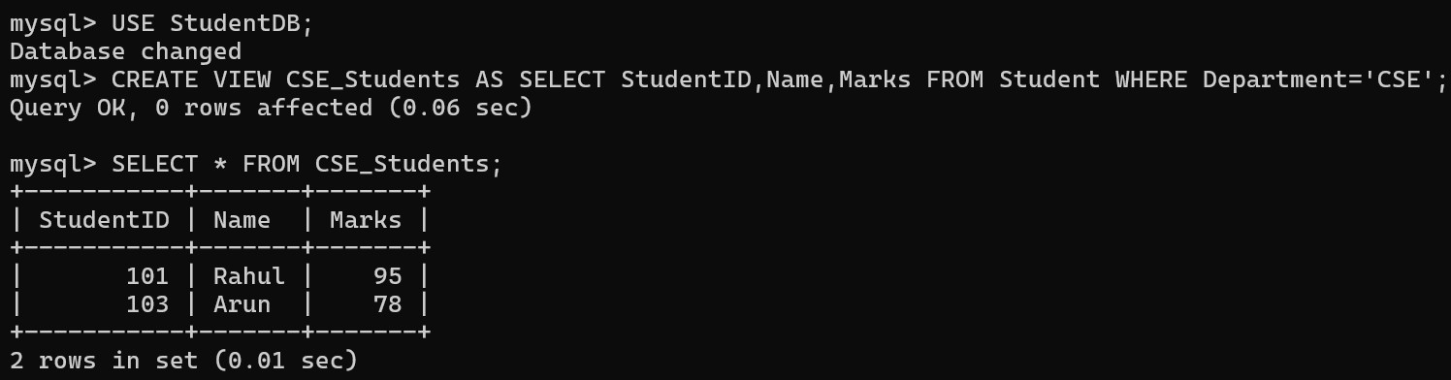

JUSTIFICATION:
- A View is a virtual table based on one or more tables.
- It provides restricted access by showing only the required columns and rows.
- It improves security by hiding unnecessary data and provides abstraction by simplifying complex queries.

QUESTION:7
Given a database schema, write relational algebra expressions and convert them into equivalent SQL queries, analyzing differences in representation.
Bloom’s Level: BL4 – Analyze

ANSWER:
RELATIONAL ALGEBRA:
πName,CourseName,Marks(σDepartment='CSE'∧ Marks>80 ∧
CourseName='DBMS'(Student ⋈ Enroll ⋈ Course))

SQL QUERY:
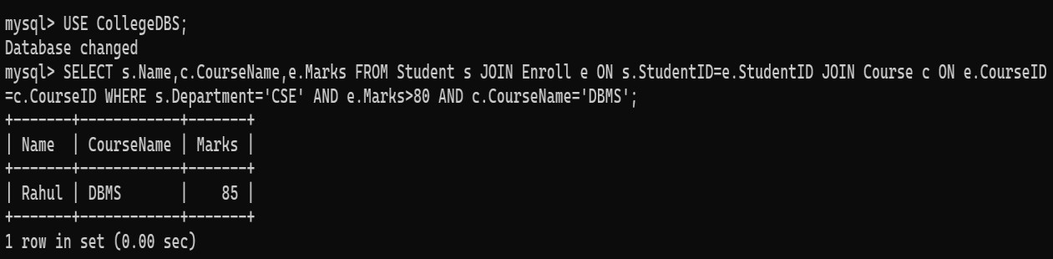

QUESTION: 8
Optimize a set of inefficient SQL queries by restructuring them using joins, indexing concepts, or views, and evaluate performance improvements.
Bloom’s Level: BL5 – Evaluate

ANSWER:
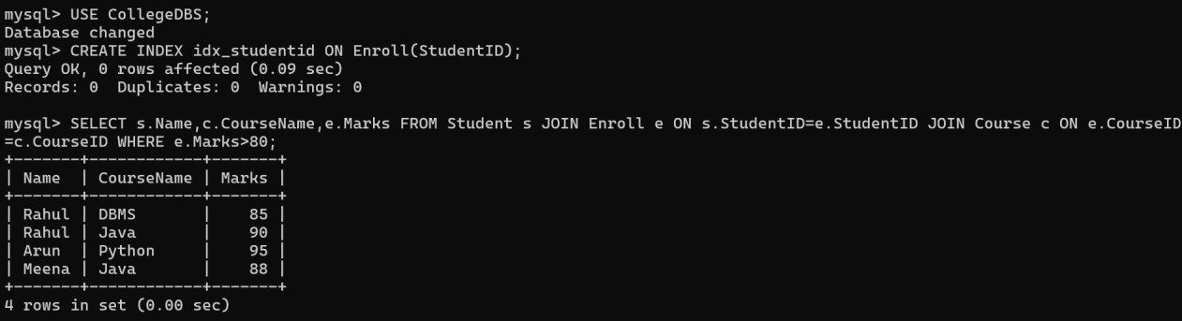
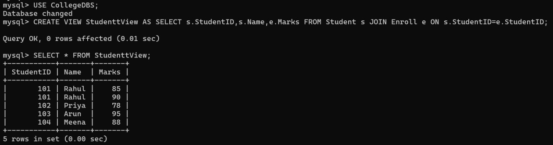

QUESTION: 9
Develop a complex SQL query involving grouping, aggregation, and nested queries to solve a real-world problem.
Bloom’s Level: BL6 – Create

ANSWER:
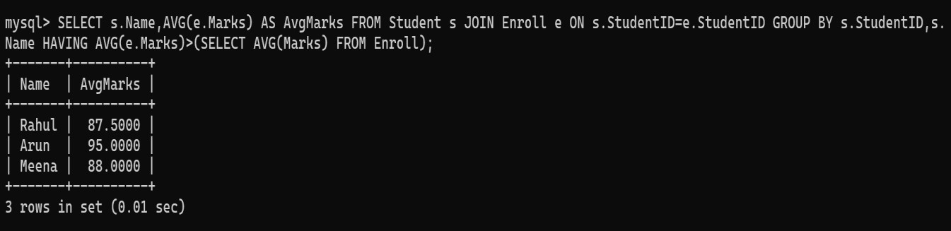

QUESTION: 10
Given multiple relations, analyze the query requirements and decide whether to use views, joins, or subqueries, justifying your choice with reasoning.
Bloom’s Level: BL5 – Evaluate

ANSWER:
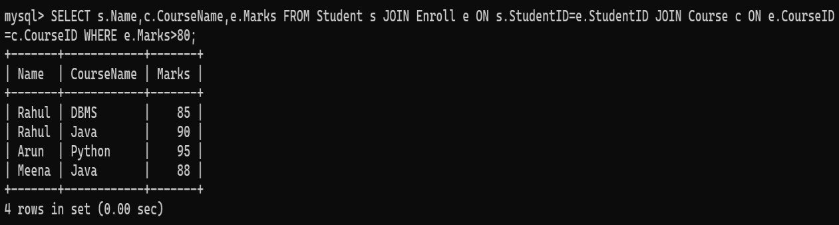

JUSTIFICATION:
- JOIN is the best choice because the required data is stored in multiple related tables (Student, Enroll, and Course).
- It retrieves all the required information in a single query.
- It is generally more efficient than subqueries for this type of retrieval.
- Views are useful for simplifying repeated queries and restricting data access, but a JOIN is more appropriate here for fetching related data from multiple tables.

